Doing Business with Los Angeles World Airports (LAWA)
Bi-Monthly Seminar
Useful Links and Contact Information for Prospective Contractors

Regional Alliance Marketplace for Procurement (RAMP)  Service: Business Opportunities Online System  https://www.rampla.org/s/ | Mayor’s Office of Community Business  Service: Offers strategic business insights  https://business.lacity.gov/resources/mayors-office-community-business  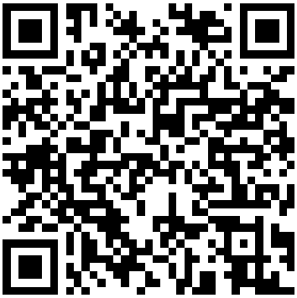  Email: mayor.communitybusiness@lacity.org
Business Job & Social Responsibility Division  Service: General information on LAWA and Business Opportunities  https://www.lawa.org/groups-and-divisions/business-jobs-and-social-responsibility/about  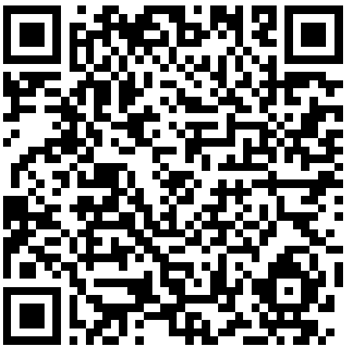  6053 W. Century Blvd., Ste 300  Los Angeles, CA 90045  424-646-7300  424-646-9257 (fax)  Email: BusinessAndJobs@lawa.org | The Department of Public Works, Bureau of Contract Administration  Service: DBE/MBE/WBE/SLBE Certification  https://bca.lacity.gov/  City of Los Angeles  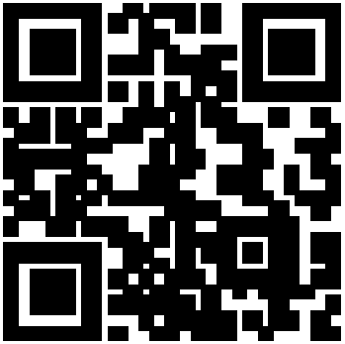  1149 S. Broadway, Suite 300  Los Angeles, CA 90015  213-847-2684  213-847-2777 (fax)
Strategic Sourcing Division (Purchasing Services)  Service: Information on current business opportunities  https://www.lawa.org/lawa-businesses/lawa-contracting-process  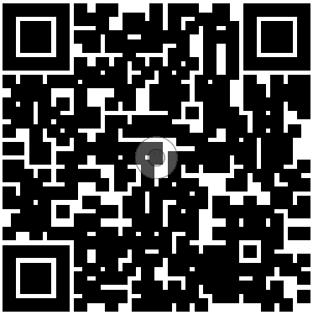  Los Angeles World Airports  7301 World Way West, 4th Floor  Los Angeles, CA 90045  424-646-7392  424-646-9274 (fax)  E-mail: procurementrequirements@lawa.org | City of Los Angeles Bond Assistance Program  (Rosa Osorio, Surety Specialist: rosorio@lawa.org)  Service: Bid, Performance and Payment Bond, Guarantees to Surety Companies  https://imwis.com/  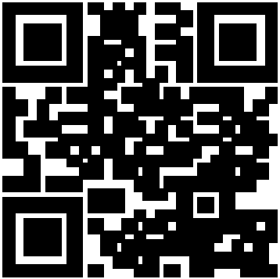  Merriwether & Williams  Insurance Services  523 W. 6th Street, Suite 650  Los Angeles, CA 90014  213-258-3000  213-258-3099 (fax)
Strategic Sourcing Division (Contract Services)  Service: Administrative Requirements and Contract Compliance  https://www.lawa.org/lawa-businesses/lawa-administrative-requirements  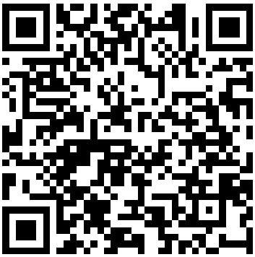  Los Angeles World Airports  7301 World Way West, 4th Floor  Los Angeles, CA 90045  424-646-5380  424-646-9262 (fax)  E-mail: procurementrequirements@lawa.org | Insurance Compliance Section  Service: Info/Help Desk on Insurance Requirements  https://www.lawa.org/lawa-businesses/lawa-administrative-requirements/insurance  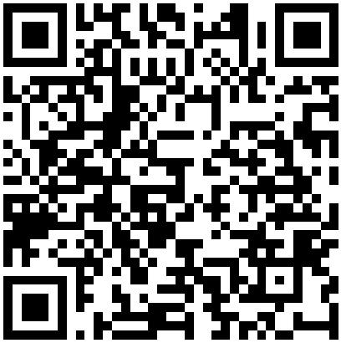  Los Angeles World Airports  7301 World Way West, 2nd Floor  Los Angeles,CA 90045  424-646-5480  Email: riskinsurance@lawa.org

